WEB DEVELOPMENT PART 2 IMPROVEMENTS
ST10507924
WEDE 5020

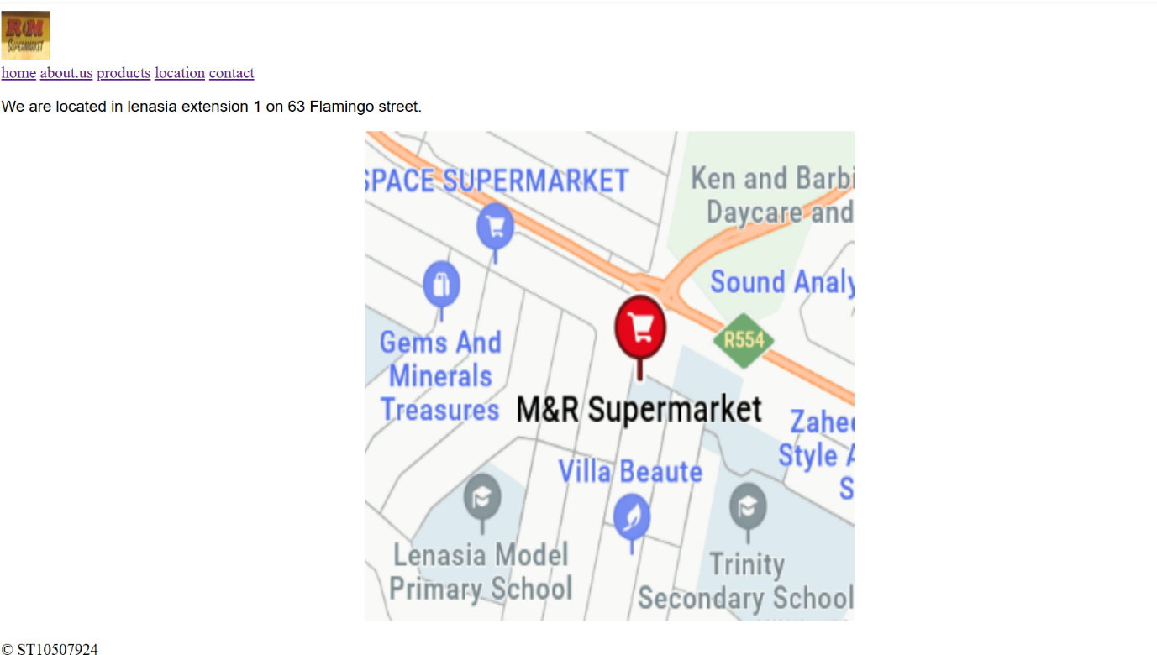
BEFORE
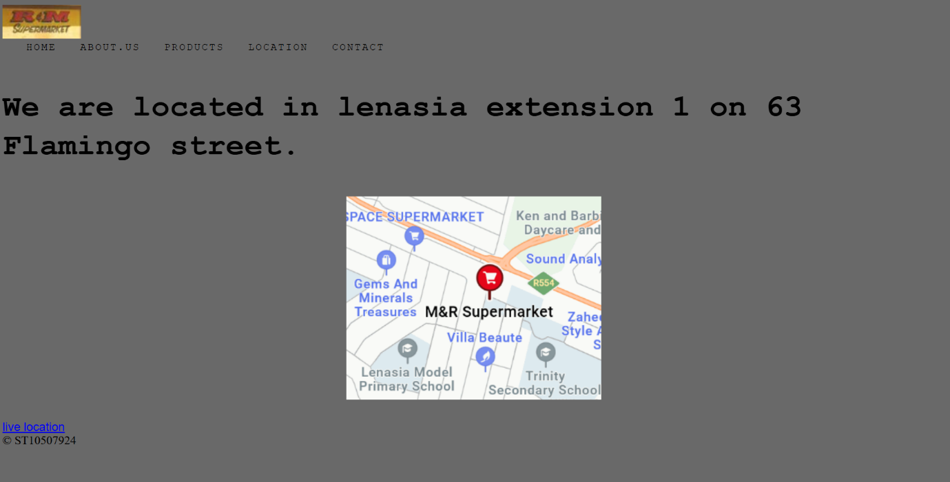
AFTER

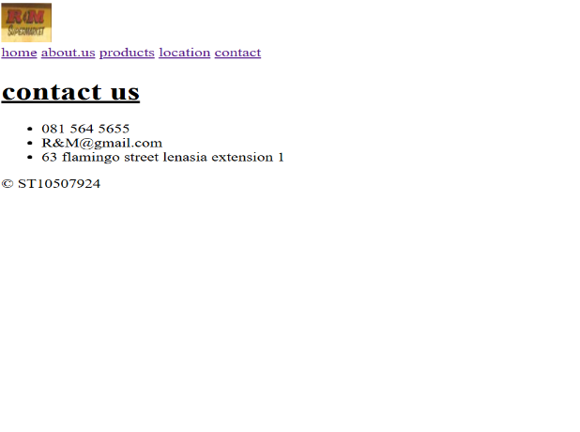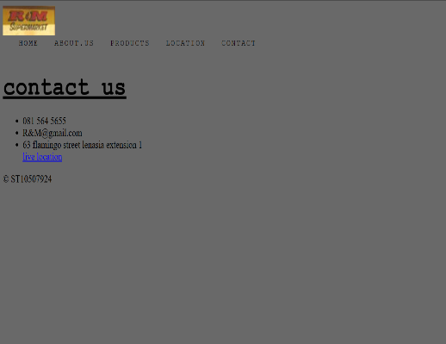
BEFORE AFTER

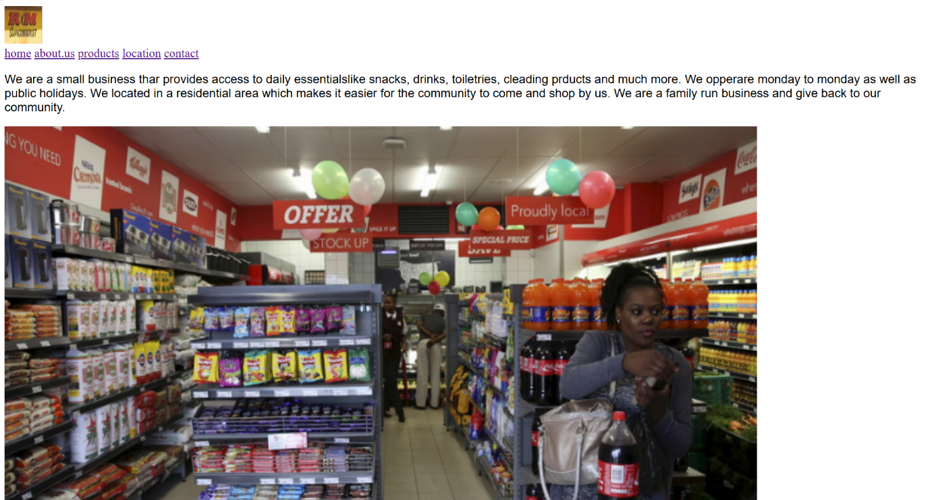
BEFORE
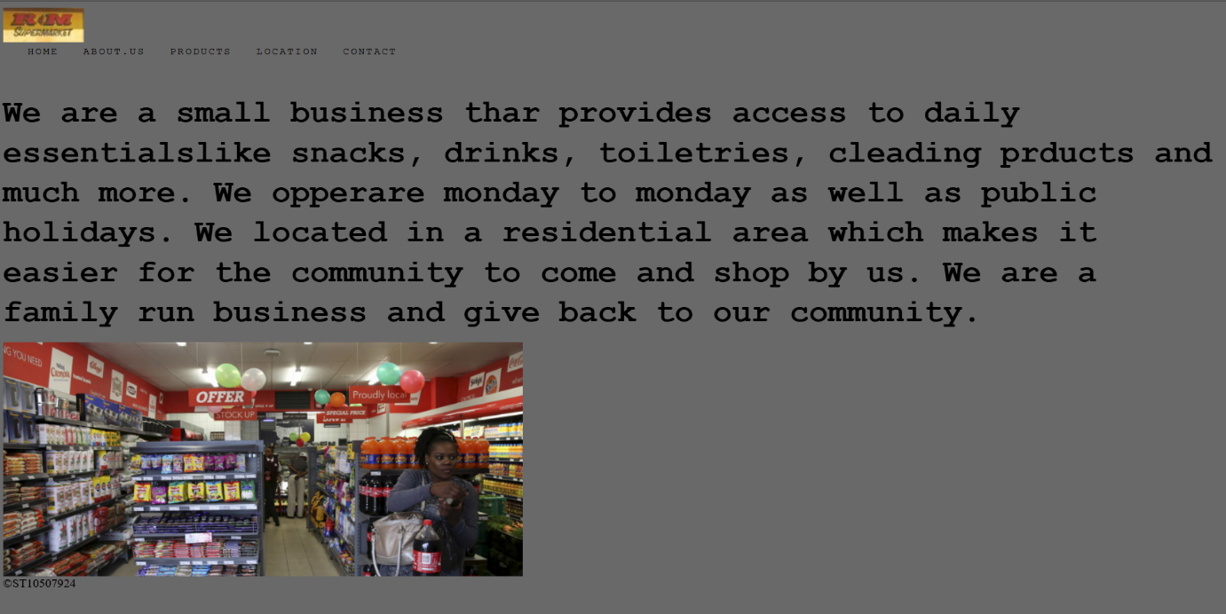
AFTER

The improvements I’ve done:

On all the web pages I’ve changed the navigation bar as well as mode the font a little bigger and separated each link. This was because the hyper links were next to each other and they were squashed and they were not clear.
I’ve changed the font family, size, weight and as well as the letter spacing. I’ve made the words bigger so that it is easier for the reader to see.
I also put in a link where people can click it to see the exact location of the shop so that they go to the correct shop.
I’ve made the images smaller as I thought it was to big and made the page looked cramped.
On my product page I put images with rounded corners as I thought it looked neater as well as I made the images smaller as I on the old web page the images were not all the same size (length and height), and the reason I removed the product prices is because they can change with market trends
I changed the font because it looked basic and like the words never stopped.

